
AMERICAN INTERNATIONAL
UNIVERSITY-BANGLADESH
Faculty of Science and Technology
Lab report

Date of Submission: | 4 January 2026
Course Title: | COMPUTER NETWORK
Course Code: | COE3206 |  | Section: | I
Semester: | Fall | 2025-26 | Course Teacher:
  Dr. Rajarshi Roy
  Chowdhury

Group Name/No.:

No | Name | ID | Program | Signature
1 | Shahriar Adnan Ishty | 22-43377-2 | BSc [CSE]

Lab-1
Experiment-1: Setting up DHCP server , WEB server , DNS server and EMAIL server in a network where there is two switches , all the servers and a pc in connected in together in a switch and one pc is connected in another switch . both switches are connected.

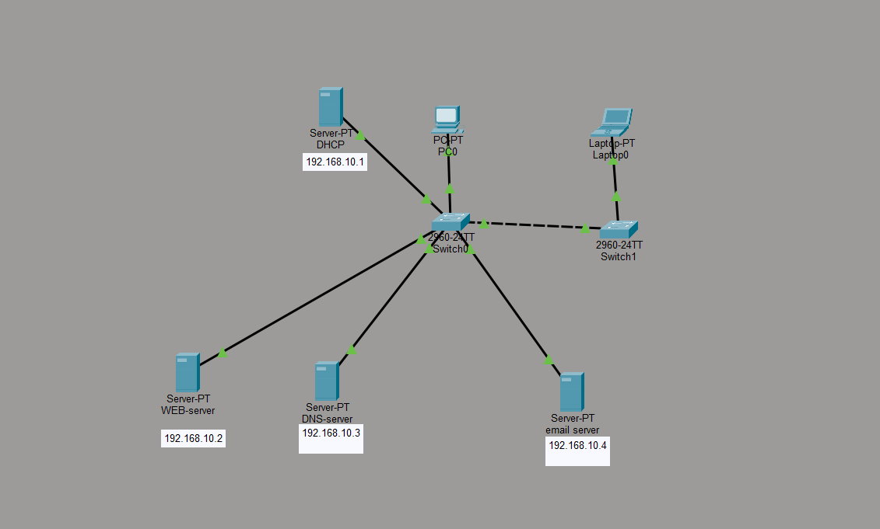

Description:
• Two switches are connected directly to each other via a cross-over cable to form a single local network.
• The network operates within a single subnet: 192.168.10.0/24.
• Four dedicated servers are connected to the primary switch (Switch0) to provide centralized services:
DHCP Server (192.168.10.1): Automatically assigns IP addresses to client devices.
WEB Server (192.168.10.2): Hosts HTTP services.
DNS Server (192.168.10.3): Handles domain name resolution.
Email Server (192.168.10.4): Manages mail communication.
• End-user devices (PC0 and Laptop0) are distributed across both switches.
• Devices on the network can connect using either dynamic (DHCP) or static IP configurations.
• This setup demonstrates the integration of multiple application-layer servers (Web, DNS, Email) and infrastructure services (DHCP) within a switched LAN environment.
Procedure:
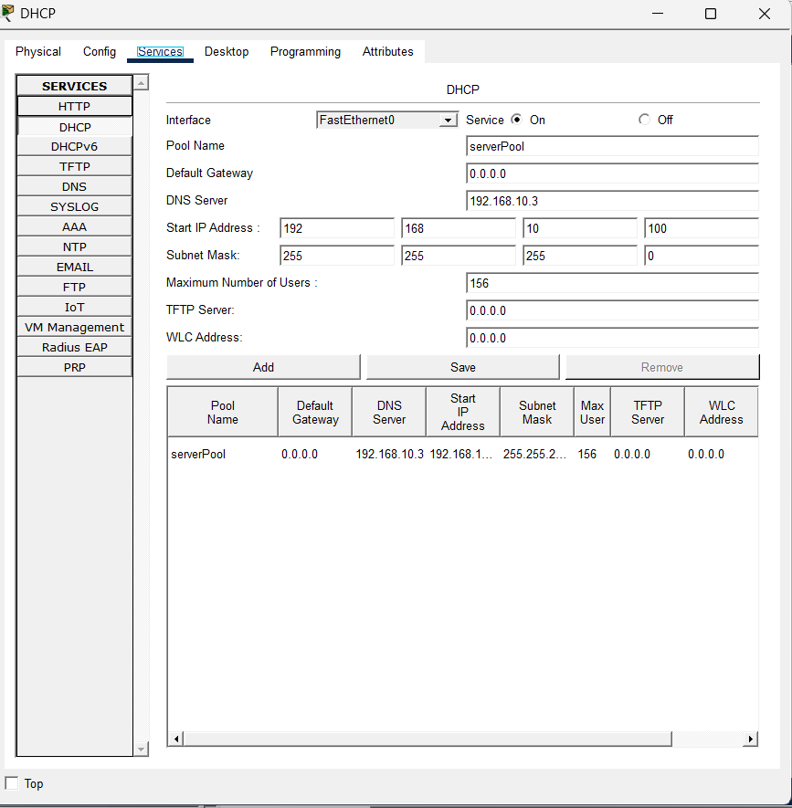
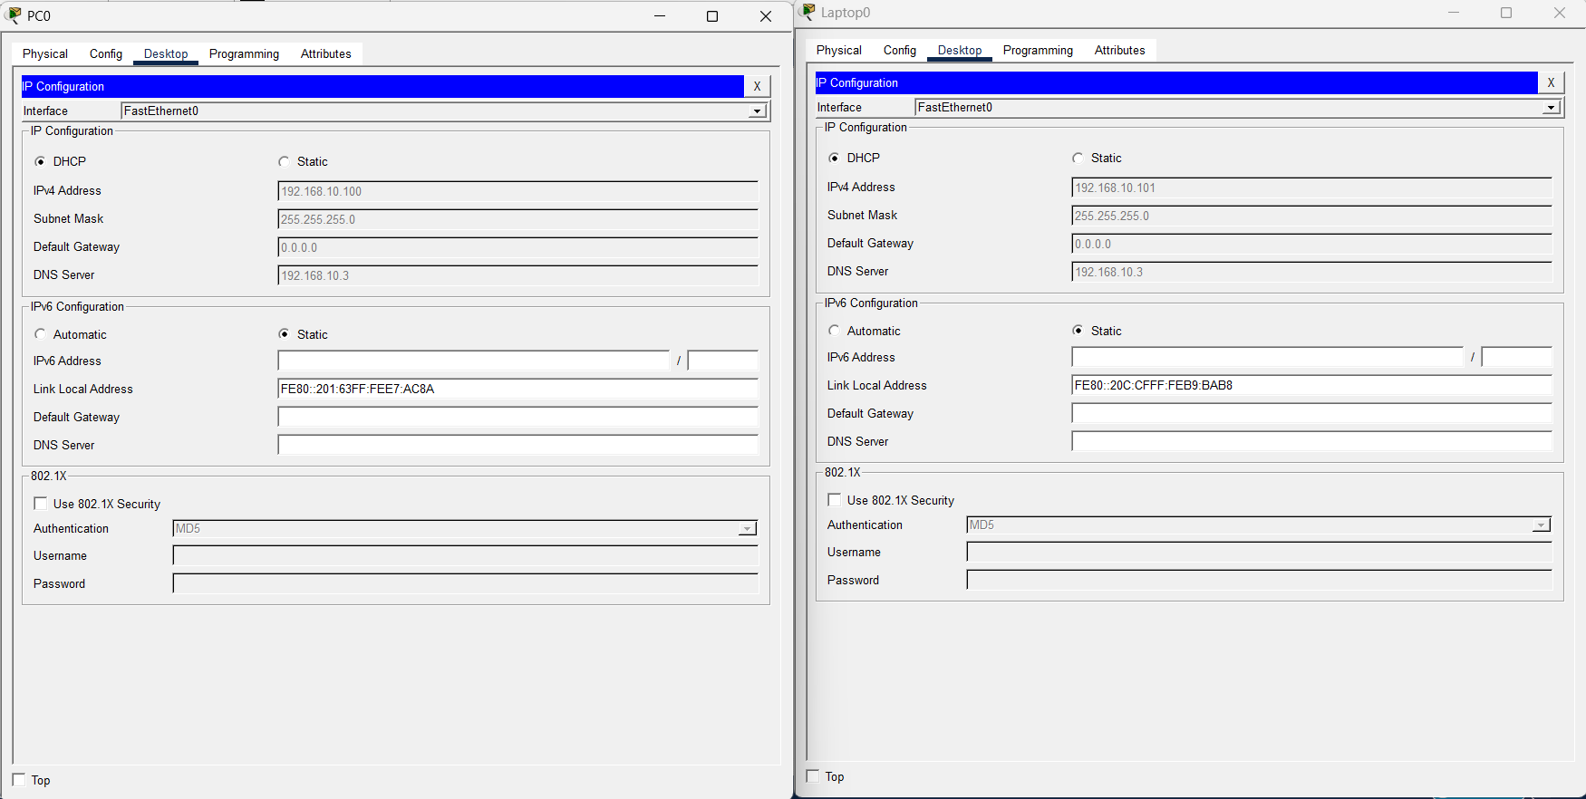
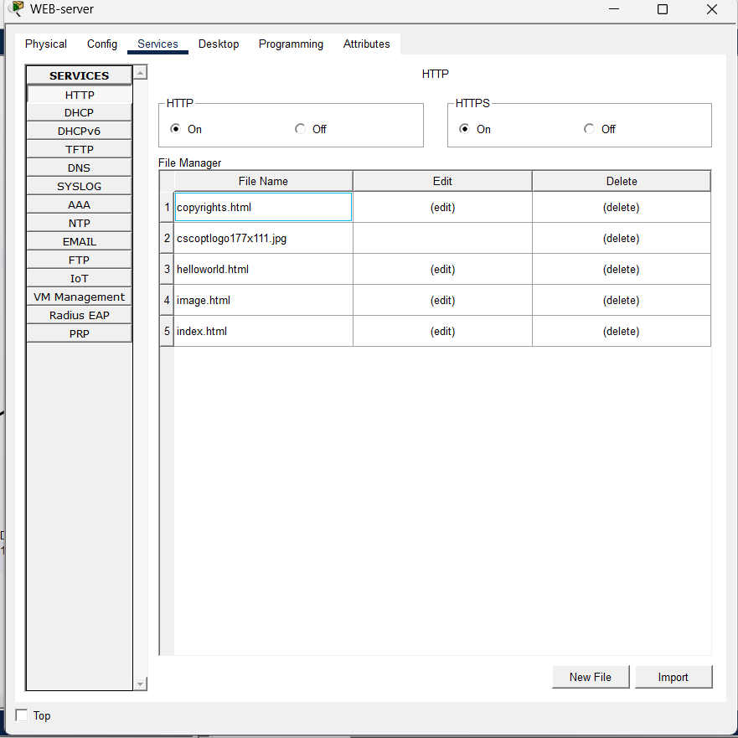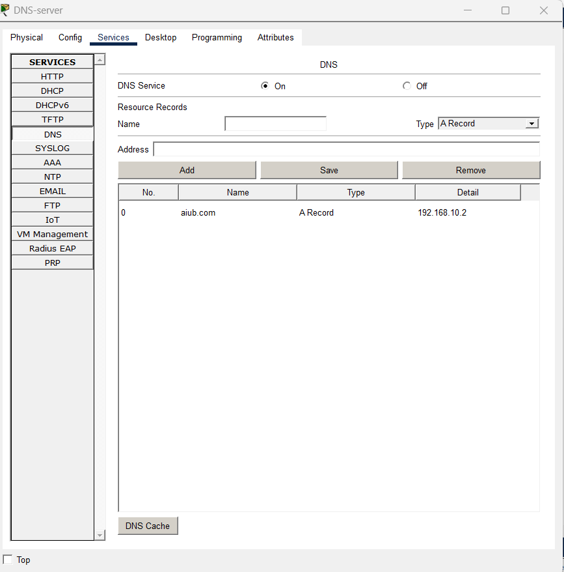
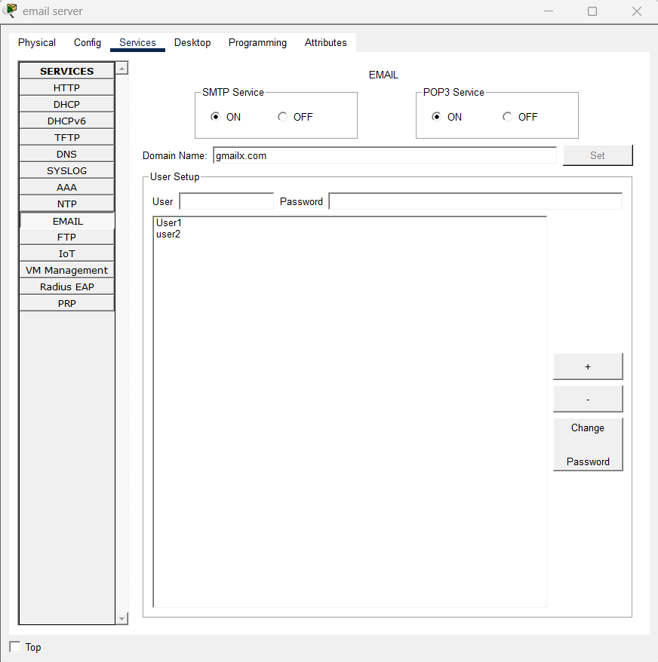

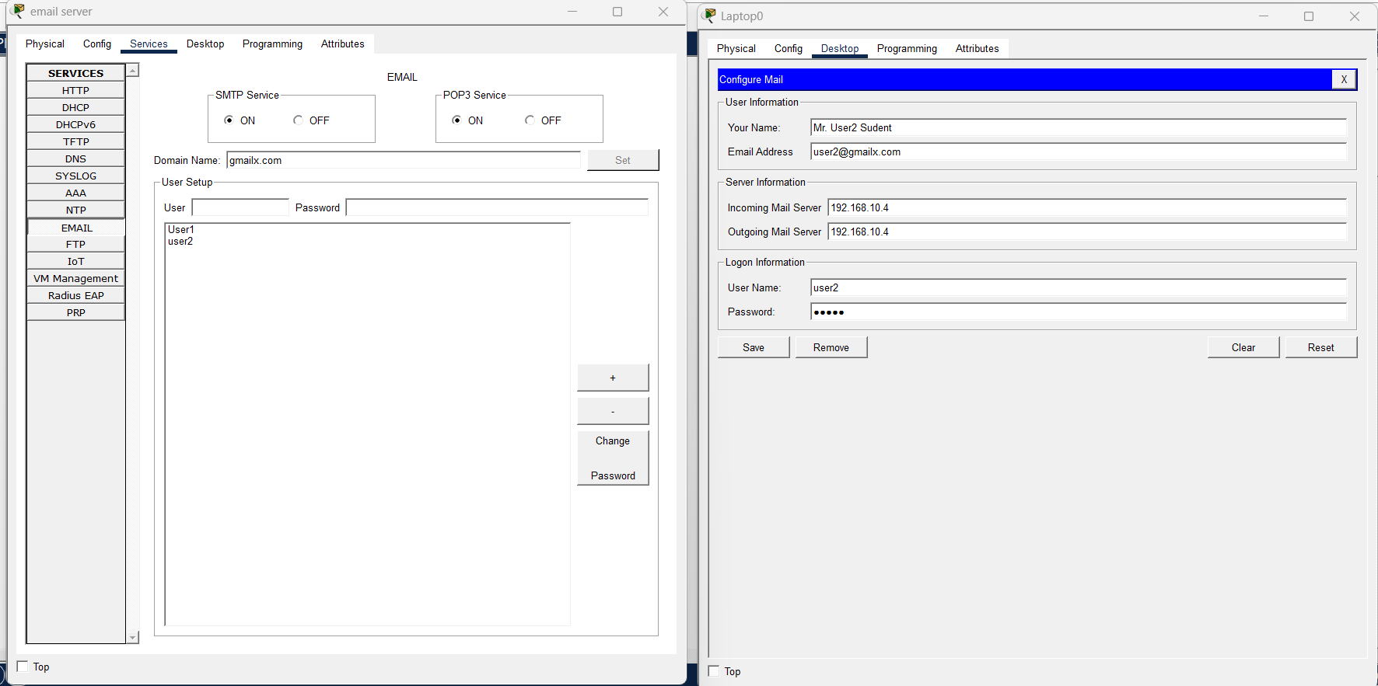

Lab-1
Experiment-2: creating three vlan in a router with two switch and 6 pc.
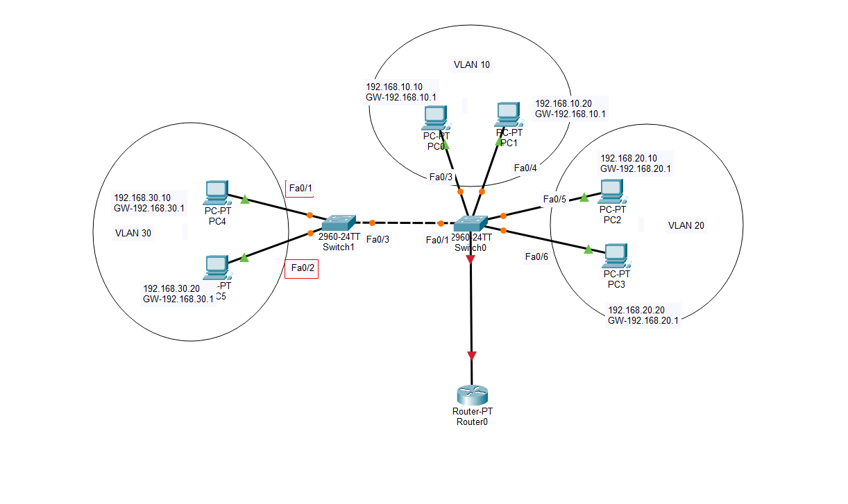

Description:
- Two switches are connected to a single router to facilitate inter-VLAN routing for three distinct logical networks.
- The network is divided into three VLANs, each operating on its own subnet with a dedicated default gateway:
  - VLAN 10: Subnet 192.168.10.0, using 192.168.10.1 as its default gateway.
  - VLAN 20: Subnet 192.168.20.0, using 192.168.20.1 as its default gateway.
  - VLAN 30: Subnet 192.168.30.0, using 192.168.30.1 as its default gateway.
- The router (Router0) acts as the central gateway, providing communication between the different VLANs (Inter-VLAN routing).
- Switch0 acts as the main distribution point, connecting to the router and hosting PCs for VLAN 10 and VLAN 20.
- Switch1 is connected to Switch0 via a trunk link (dashed line), extending the network to host PCs for VLAN 30.
- A total of 6 PCs are deployed, with two devices assigned to each VLAN to test connectivity within and across subnets.
- This setup demonstrates how a Router-on-a-Stick or multi-interface router configuration allows logically separated broadcast domains (VLANs) to communicate securely in a multi-switch environment.
Procedure:

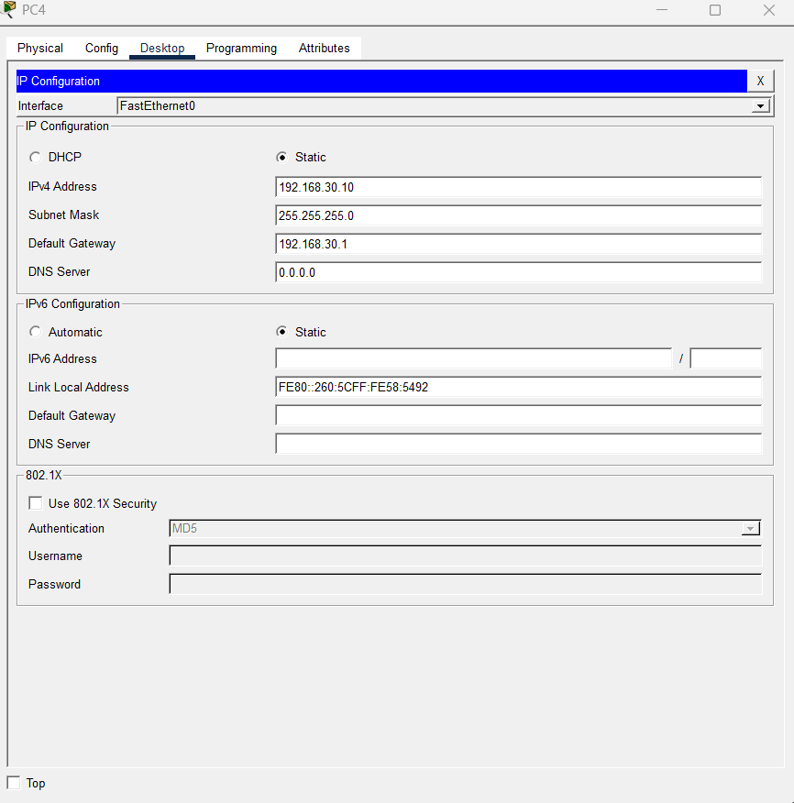

Cli script:

Switch0:
configure terminal
vlan 10
vlan 20
vlan 30
exit
interface fa0/1
switchport mode trunk
interface fa0/2
switchport mode trunk
interface range fa0/3 - 4
switchport mode access
switchport access vlan 10
interface range fa0/5 - 6
switchport mode access
switchport access vlan 20

Switch1:
configure terminal
vlan 30
exit
interface fa0/3
switchport mode trunk
interface range fa0/1 - 2
switchport mode access
switchport access vlan 30

Router:
configure terminal
interface fa0/0
no shutdown
interface fa0/0.10
encapsulation dot1Q 10
ip address 192.168.10.1 255.255.255.0
interface fa0/0.20
encapsulation dot1Q 20
ip address 192.168.20.1 255.255.255.0
interface fa0/0.30
encapsulation dot1Q 30
ip address 192.168.30.1 255.255.255.0
exit

Lab-2
Experiment-1: creating four vlan in a router with three switch and 8 pc.

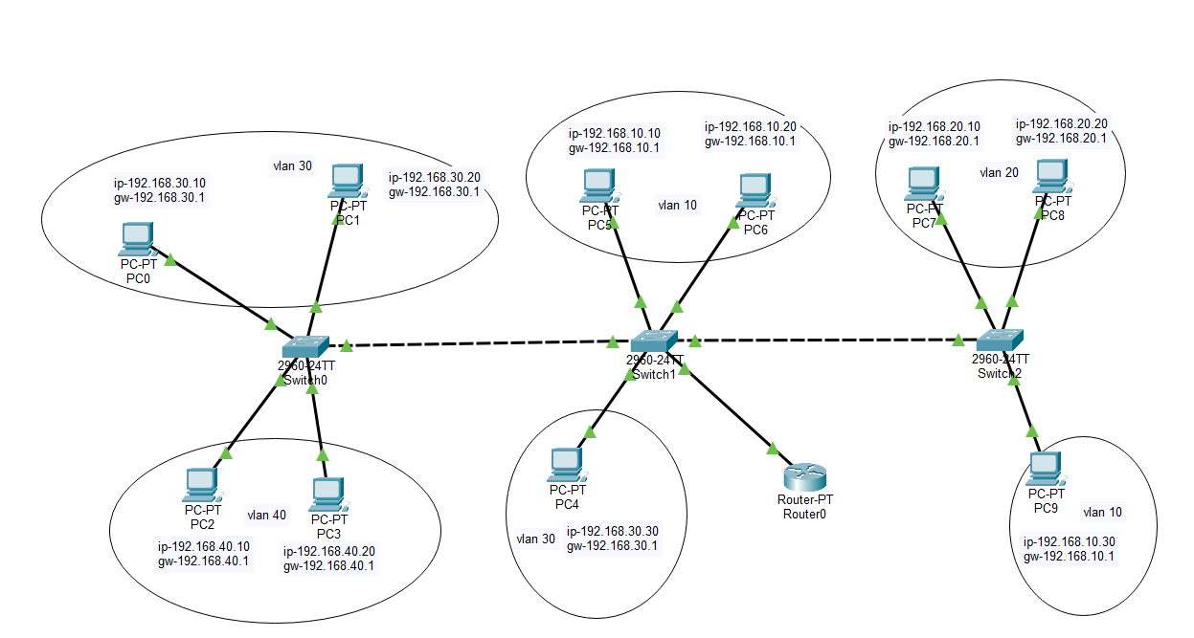

Description:
• Three switches are interconnected via trunk links to a single router to facilitate inter-VLAN routing for four distinct logical networks.
• The network is divided into four VLANs, each operating on its own subnet with a dedicated default gateway:
- VLAN 10: Subnet 192.168.10.0, gateway 192.168.10.1.
- VLAN 20: Subnet 192.168.20.0, gateway 192.168.20.1.
- VLAN 30: Subnet 192.168.30.0, gateway 192.168.30.1.
- VLAN 40: Subnet 192.168.40.0, gateway 192.168.40.1.
• The router (Router0) acts as the central gateway, connected to the middle switch (Switch1) to provide communication between all subnets.
• The switches (Switch0, Switch1, Switch2) use trunking to share VLAN information across the entire network.
• A total of 10 PCs are deployed across the switches, assigned to various VLANs to test traffic flow across multiple hardware segments.
• This setup demonstrates advanced Inter-VLAN routing using a "Router-on-a-Stick" configuration in a multi-switch environment.
Cli script:

Router0
configure terminal
interface fa0/0
no shutdown
interface fa0/0.10
encapsulation dot1Q 10
ip address 192.168.10.1 255.255.255.0
interface fa0/0.20
encapsulation dot1Q 20
ip address 192.168.20.1 255.255.255.0
interface fa0/0.30
encapsulation dot1Q 30
ip address 192.168.30.1 255.255.255.0
interface fa0/0.40
encapsulation dot1Q 40
ip address 192.168.40.1 255.255.255.0
exit

Switch1:
configure terminal
vlan 10
vlan 20
vlan 30
vlan 40
exit
interface range fa0/1 - 3
switchport mode trunk
interface range fa0/4 - 5
switchport mode access
switchport access vlan 10
interface fa0/6
switchport mode access
switchport access vlan 30

Switch0:
configure terminal
vlan 30
vlan 40
exit
interface fa0/1
switchport mode trunk
interface range fa0/2 - 3
switchport mode access
switchport access vlan 30
interface range fa0/4 - 5
switchport mode access
switchport access vlan 40

Switch 2:
configure terminal
vlan 10
vlan 20
exit
interface fa0/1
switchport mode trunk
interface range fa0/2 - 3
switchport mode access
switchport access vlan 20
interface fa0/4
switchport mode access
switchport access vlan 10

Lab-2
Experiment-2: controlling IoT devices remotely using DHCP server
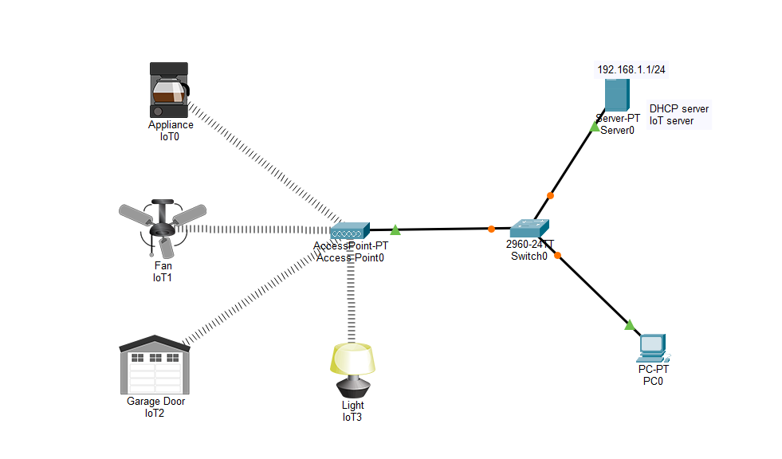
Description:
• A central switch (Switch0) connects a server, a workstation (PC0), and a wireless Access Point (AccessPoint0).
• The server (Server0) performs dual roles as both a DHCP server for IP assignment and an IoT registration server for device management.
• The network operates on the 192.168.1.0/24 subnet, with the server statically assigned to 192.168.1.1.
• Four IoT devices (Appliance, Fan, Garage Door, and Light) are connected wirelessly to the Access Point.
• The Access Point acts as a bridge, allowing wireless IoT devices to communicate with the wired infrastructure.
• PC0 is used as the management console to log into the IoT server and control the devices remotely.
• This setup demonstrates how centralized DHCP and IoT services allow for the automated configuration and remote monitoring of smart home devices.

Procedure:
